Mobile Application Lab Exercise 3

Exercise 3A
Creating a Mobile App (see below) by following the steps below.
- Open Android Studio and create a new Mobile App called MyLab3App, and make sure you are selecting JAVA programming language.
- Wait until the Mobile App completed its settings
- Open the file activity_main.xml in design mode, and create FOUR TextView field, TWO editable Text, and ONE buttons (see below)
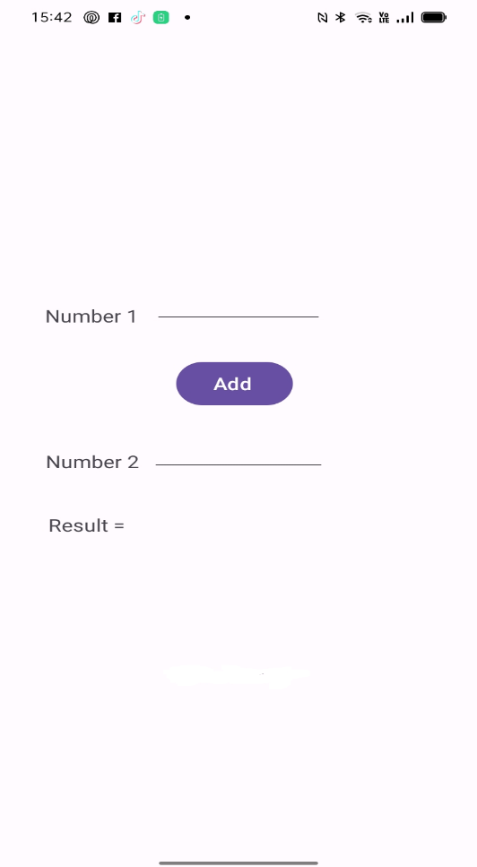

  - Remove the TextView “Hello Word!” from the screen
  - In the Palette menu to the left of the phone display, find TextView
  - Click and drag TextView and position it to the left side of the screen
  - In the attribute menu to the right of the phone display, find text option and type Number 1 instead of TextView (see the image above)
  - In the Palette menu to the left of the phone display, find ‘Plain Text’, and click and drag and place it to the right side of ‘Number 1’ (see the image above)
  - In the attribute menu to the right of the phone display, find id option and type editNo1
  - In the Palette menu to the left of the phone display, find Button, click and drag Button to be centred underneath your Plain Text (editNo1) (see the image above)
  - In the attribute menu to the right of the phone display, find text option and type Add instead of Button (see the image above)
  - In the Palette menu to the left of the phone display, find TextView Click and drag TextView and place it to the left side of the screen, and underneath your ‘Number 1’
  - In the attribute menu to the right of the phone display, find text option and type Number 2 instead of TextView (see the image above)
  - In the Palette menu to the left of the phone display, find ‘Plain Text’, and click and drag and place it to the right side of ‘Number 2’ (see the image above)
  - In the attribute menu to the right of the phone display, find id option and type editNo2
  - In the Palette menu to the left of the phone display, find TextView
  - Click and drag TextView and position it to the left side of the screen, underneath your ‘Number 2’
  - In the attribute menu to the right of the phone display, find text option and type ‘Result = ‘ instead of TextView (see the image above).
  - In the Palette menu to the left of the phone display, find TextView Click and drag TextView and place it to the right side of the position it to the right side of ‘Result =’, and underneath your ‘editNo2’
  - In the attribute menu to the right of the phone display, find id option and type ‘result’

- Open the file MainActivity.java, and add the following codes before the end of onCreate() method;
EditText num1 = findViewById(R.id. editNo1);
EditText num2 = findViewById(R.id. editNo2);
TextView result = findViewById(R.id. result);

Button button = findViewById(R.id.button);
button.setOnClickListener(new OnClickListener() {
@Override
public void onClick(View v) {

double numb1 = Double.parseDouble(num1.getText().toString());
double numb2 = Double.parseDouble(num2.getText().toString());
double res= numb1 + numb2;
result.setText(String.format("%.2f", new BigDecimal(res)));

}
});

- Import the package import android.util.Log;
- Add the Lifecycle methods to your project after onCreate() method. For example
@Override
protected void onStart() {
super.onStart(); // The activity is between stopped and started.
Log.d("Lifecycle", "onStart called");
}

- After adding all the lifecycle methods and running your App. Click on Logcat option to see the information about these lifecycle methods.

Exercise 3B
Creating a Mobile App (see below) by following the steps below.
- Open Android Studio and create a new Mobile App called MyLab3bApp, and make sure you are selecting JAVA programming language.
- Wait until the Mobile App completed its settings
- Open the file activity_main.xml in design mode, and create ONE TextClock field, and TWO buttons (see below)

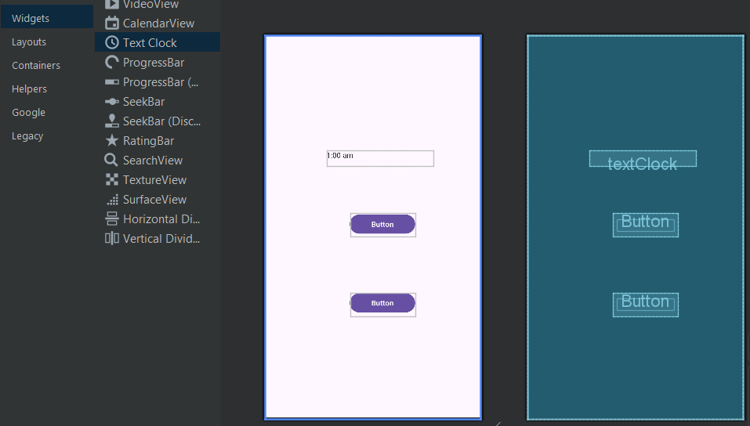
  - Click the TextView “Hello Word!” and move it to the top of the screen
  - In the Palette menu to the left of the phone display, find TextClock, click and drag the TextClock and place it in the top of the screen.
  - In the attribute menu to the right of the phone display, find id option and type myClock
  - In the Palette menu to the left of the phone display, find Button, click and drag Button to be centred underneath your TextClock (myClock) (see the image above)
  - In the attribute menu to the right of the phone display, find text option and type ‘TIME IN UK’ instead of Button (see the image below)
  - In the Palette menu to the left of the phone display, find Button, click and drag Button to be centred underneath your Button (TIME IN UK) (see the image below)
  - In the attribute menu to the right of the phone display, find text option and type ‘TIME IN INDIA’ instead of Button (see the image below)

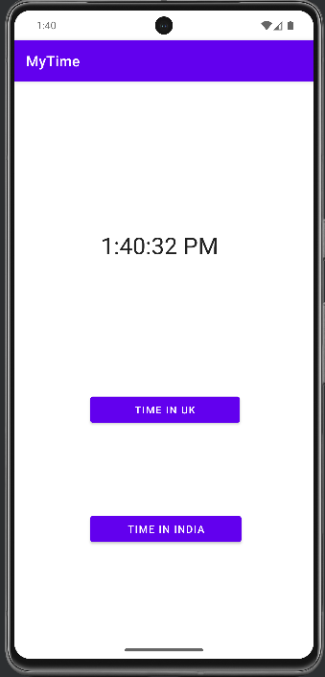

- Open the file MainActivity.java, and add the following codes before the end of onCreate() method;
TextClock mytime =findViewById(R.id.myClock);
Button But1 = findViewById(R.id.Butt1);
Button But2 = findViewById(R.id.Butt2);
But1.setOnClickListener(new View.OnClickListener() {
@Override
public void onClick(View v) {
mytime.setTimeZone("Europe/London");
}
});
But2.setOnClickListener(new View.OnClickListener() {
@Override
public void onClick(View v) {
mytime.setTimeZone("Asia/Kolkata");
}
});

You can select and change the time Zone from this link https://docs.oracle.com/cd/E72987_01/wcs/tag-ref/MISC/TimeZones.html

Exercise 3C
- Open Android Studio and open MyLab3bApp project, and make sure you are selecting JAVA programming language.
- Wait until the Mobile App completed its settings
- Open the file activity_main.xml in code mode, and change the following line

<androidx.constraintlayout.widget.ConstraintLayout xmlns:android=”http://schemas.android.com/apk/res/android”

Into

<RelativeLayout xmlns:android="http://schemas.android.com/apk/res/android"

- And re-compiler and run your Mobile App, you will see all the components moved in different positions. Please try to fix and re-arrange all components correctly.
- Open the file activity_main.xml in code mode, and change the following line

<RelativeLayout xmlns:android=”http://schemas.android.com/apk/res/android”

Into

<LinearLayout xmlns:android=”http://schemas.android.com/apk/res/android”

And add this code android:orientation="vertical” before the line

tools:context=".MainActivity">

- And re-compiler and run your Mobile App, you will see all the components moved in different positions. Please try to fix and re-arrange all components correctly.

